# PRACTICAL 1

## Aim: Create the simple “hello world” program

### Activity_Main.xml

<?xml version="1.0" encoding="utf-8"?>

<androidx.constraintlayout.widget.ConstraintLayout xmlns:android="[http://schemas.android.com/apk/res/android"](http://schemas.android.com/apk/res/android)

xmlns:app="[http://schemas.android.com/apk/res-auto"](http://schemas.android.com/apk/res-auto) xmlns:tools="[http://schemas.android.com/tools"](http://schemas.android.com/tools) android:layout_width="match_parent" android:layout_height="match_parent" tools:context=".MainActivity">

<TextView android:layout_width="wrap_content" android:layout_height="wrap_content" android:text="Hello World!"

app:layout_constraintBottom_toBottomOf="parent" app:layout_constraintEnd_toEndOf="parent" app:layout_constraintStart_toStartOf="parent" app:layout_constraintTop_toTopOf="parent" />

</androidx.constraintlayout.widget.ConstraintLayout>

### MainActivity.java

package com.example.myapplication;

import androidx.appcompat.app.AppCompatActivity; import android.os.Bundle;

public class MainActivity extends AppCompatActivity {

@Override

protected void onCreate(Bundle savedInstanceState) {

super.onCreate(savedInstanceState); setContentView(R.layout.*activity_main*);

}

}

**Output**

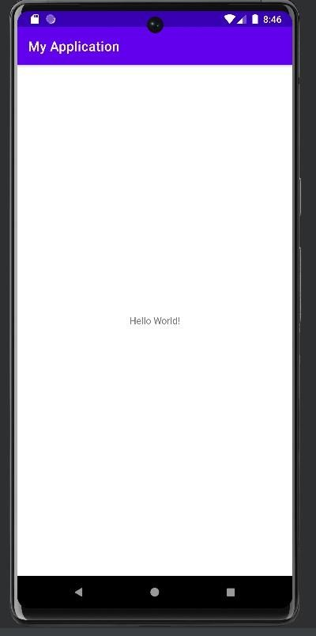

# PRACTICAL 2

## Aim: Android Resources: (Color, Theme, String, Drawable).

### Colors.xml

<?xml version="1.0" encoding="utf-8"?>

<resources>

<color name="purple_200">#FFBB86FC</color>

<color name="purple_500">#FF6200EE</color>

<color name="purple_700">#FF3700B3</color>

<color name="teal_200">#FF03DAC5</color>

<color name="teal_700">#FF018786</color>

<color name="black">#FF000000</color>

<color name="white">#FFFFFFFF</color>

</resources>

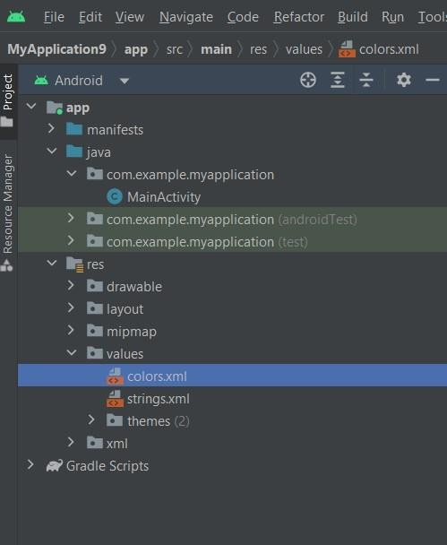

To apply color to Textview :

Using code

<TextView

android:layout_width="wrap_content" android:layout_height="wrap_content" android:background="@color/black" android:text="Hello World!"

android:textColor="#FEFEFE"

app:layout_constraintBottom_toBottomOf="parent" app:layout_constraintEnd_toEndOf="parent"

app:layout_constraintStart_toStartOf="parent" app:layout_constraintTop_toTopOf="parent" />

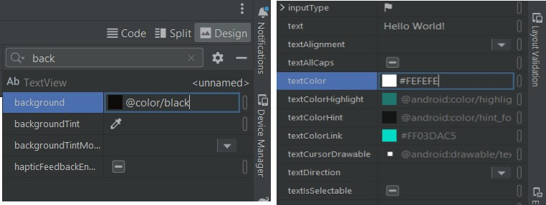Or using attributes window

Note that we can apply only those colors which are stored in Colors.xml file

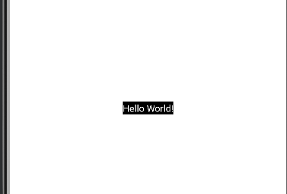

### Dimensions

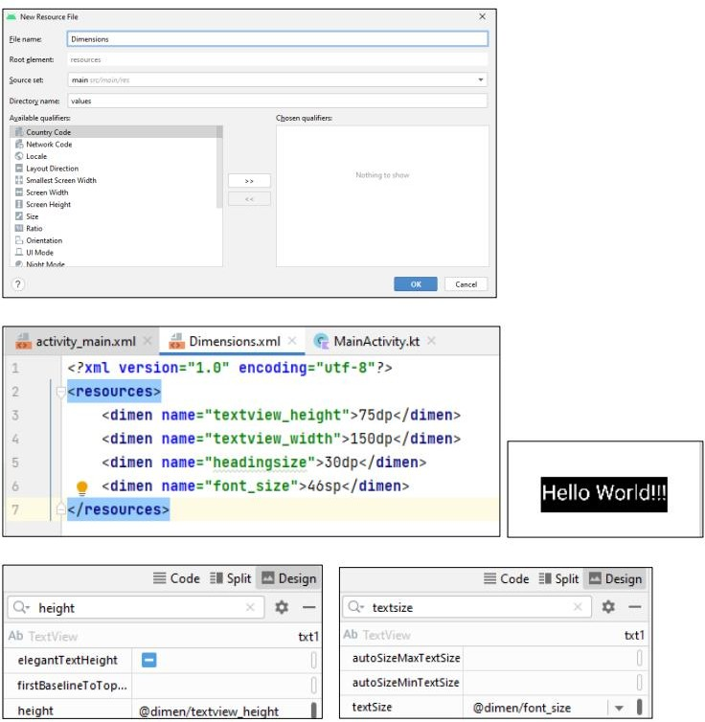

#### Theme:

Style.xml

<resources>

<!-- Base application theme. -->

<style name="AppTheme" parent="Theme.AppCompat.Light.DarkActionBar">

<!-- Customize your theme here. -->

<item name="colorPrimary">@color/colorPrimary</item>

<item name="colorPrimaryDark">@color/colorPrimaryDark</item>

<item name="colorAccent">@color/colorAccent</item>

</style>

</resources>

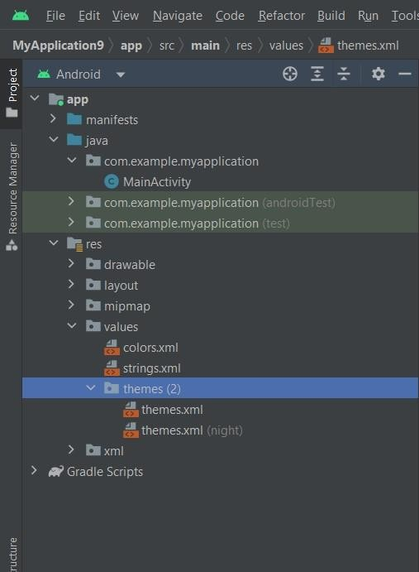

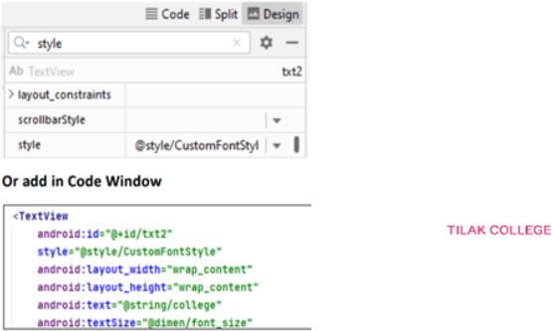

#### String.xml:

<resources>

<string name="app_name">My Application</string>

<string name="hello">Hello World!!!</string>

<string name="college"> TILAK COLLEGE </string>

<string name="contact">7058332304</string>

</resources>

Using code

<TextView android:layout_width="wrap_content" android:layout_height="wrap_content" android:text="@string/college"

app:layout_constraintBottom_toBottomOf="parent" android:textColor="@color/deeppink" app:layout_constraintEnd_toEndOf="parent" app:layout_constraintStart_toStartOf="parent" app:layout_constraintTop_toTopOf="parent" />

Output



#### Drawable:

1. Right click on drawable folder

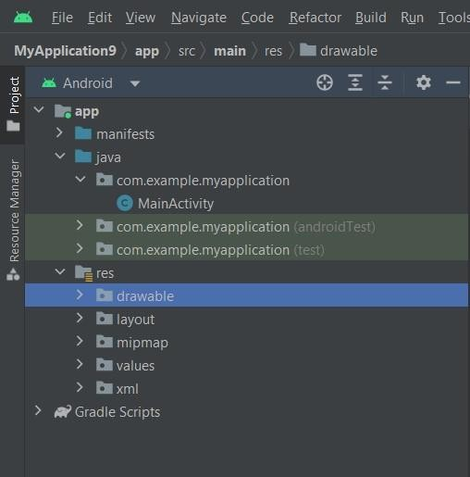

1. Copy the image if you want to create image drawable
2. Paste that image file inside the drawable folder

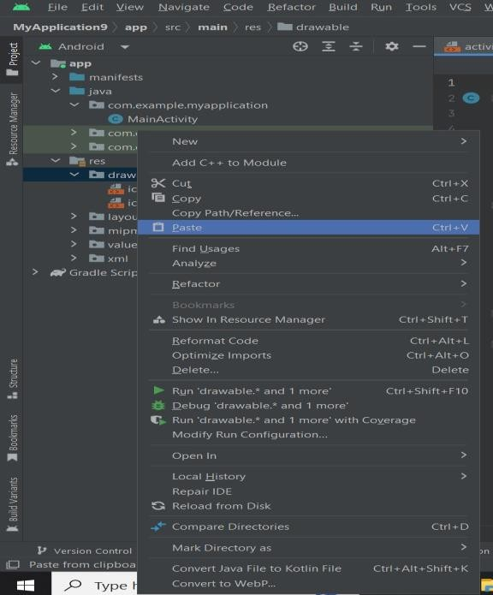

Now to apply image to background of activity -→ select activity -→ attributes -→ background→name of image

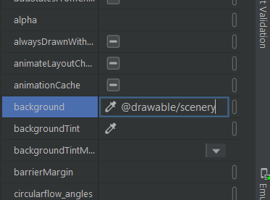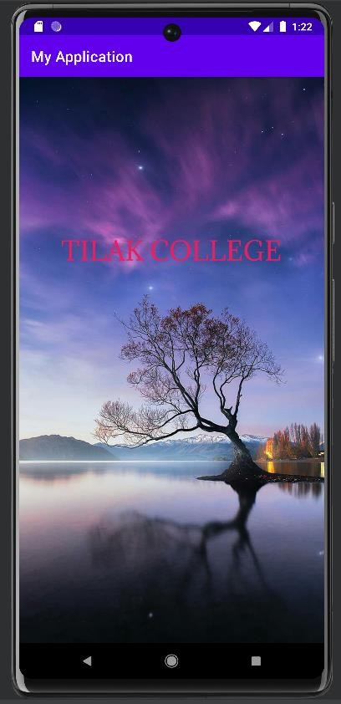

# PRACTICAL 3

## Aim: Activity Lifecycle

### MainActivity.java

package com.example.myapplication;

import androidx.appcompat.app.AppCompatActivity; import android.util.Log;

import android.os.Bundle;

public class MainActivity extends AppCompatActivity { String tag = "LifeCycle";

@Override

protected void onCreate(Bundle savedInstanceState) { super.onCreate(savedInstanceState);

setContentView(R.layout.*activity_main*); Log.*d*(tag, "In the onCreate()event");

}

public void onStart() { super.onStart();

Log.*d*(tag, "In the onStart()event");

}

public void onRestart() { super.onRestart();

Log.*d*(tag, "In the onRestart()event");

}

public void onResume() { super.onResume();

Log.*d*(tag, "In the onResume()event");

}

public void onPause() { super.onPause();

Log.*d*(tag, "In the onPause()event");

}

public void onStop() { super.onStop();

Log.*d*(tag, "In the onStop()event");

}

public void onDestroy() { super.onDestroy();

Log.*d*(tag, "In the onDestroy()event");

}

}

**Output**

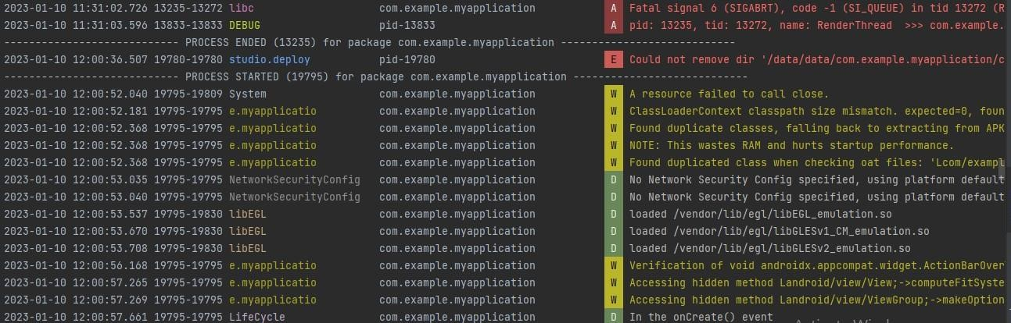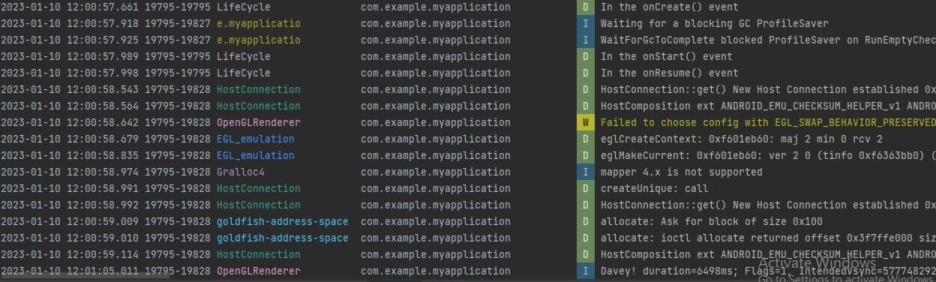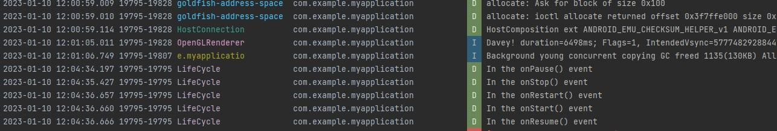

# PRACTICAL 4

## Aim: Create the login form using different layout

### Activity_Main.xml

<?xml version="1.0" encoding="utf-8"?>

<RelativeLayout xmlns:android="[http://schemas.android.com/apk/res/android"](http://schemas.android.com/apk/res/android) xmlns:app="[http://schemas.android.com/apk/res-auto"](http://schemas.android.com/apk/res-auto) xmlns:tools="[http://schemas.android.com/tools"](http://schemas.android.com/tools) android:layout_width="match_parent" android:layout_height="match_parent"

tools:context=".MainActivity">

<TextView android:id="@+id/textview"

android:layout_width="wrap_content" android:layout_height="wrap_content" android:layout_alignParentTop="true" android:layout_centerHorizontal="true" android:text="Login Example" android:textSize="35dp" />

<EditText

android:layout_width = "wrap_content" android:layout_height = "wrap_content" android:id = "@+id/editText" android:hint = "Enter Name" android:focusable = "true" android:textColorHighlight = "#ff7eff15" android:layout_marginTop = "46dp" android:layout_alignParentLeft = "true" android:layout_alignParentStart = "true" android:layout_alignParentRight = "true"

android:layout_alignParentEnd = "true" />

<EditText android:layout_width="wrap_content" android:layout_height="wrap_content" android:inputType="textPassword" android:ems="10"

android:id="@+id/editText2" android:layout_below="@+id/editText" android:layout_alignParentLeft="true" android:layout_alignParentStart="true" android:layout_alignRight="@+id/editText" android:layout_alignEnd="@+id/editText" android:hint="Password" />

<TextView android:id="@+id/textView2" android:layout_width="wrap_content" android:layout_height="wrap_content"

android:layout_below="@+id/editText2" android:layout_alignParentStart="true" android:layout_alignParentLeft="true" android:text="Attempts Remaining" android:textSize="25dp" />

<TextView android:id="@+id/textView3" android:layout_width="wrap_content" android:layout_height="wrap_content"

android:layout_alignTop="@+id/textView2" android:layout_alignBottom="@+id/textView2" android:layout_alignParentEnd="true" android:layout_alignParentRight="true" android:layout_toEndOf="@+id/textview" android:layout_toRightOf="@+id/textview" android:text="Text"

android:textSize="25dp" />

<Button

android:layout_width="wrap_content" android:layout_height="wrap_content" android:text="login" android:id="@+id/button" android:layout_alignParentBottom="true" android:layout_toLeftOf="@+id/textview" android:layout_toStartOf="@+id/textview" />

<Button

android:layout_width="wrap_content" android:layout_height="wrap_content"

android:text="Cancel" android:id="@+id/button2" android:layout_alignParentBottom="true" android:layout_toRightOf="@+id/textview" android:layout_toEndOf="@+id/textview" />

</RelativeLayout>

### MainActivity.java

package com.example.myapplication;

import androidx.appcompat.app.AppCompatActivity; import android.os.Bundle;

import android.graphics.Color;

import android.view.View; import android.widget.Button; import android.widget.EditText; import android.widget.TextView; import android.widget.Toast;

public class MainActivity extends AppCompatActivity { Button b1,b2;

EditText ed1,ed2; TextView tx1;

int counter = 3;

@Override

protected void onCreate(Bundle savedInstanceState) { super.onCreate(savedInstanceState); setContentView(R.layout.*activity_main*);

b1 = (Button)findViewById(R.id.*button*);

ed1 = (EditText)findViewById(R.id.*editText*); ed2 = (EditText)findViewById(R.id.*editText2*); b2 = (Button)findViewById(R.id.*button2*);

tx1 = (TextView)findViewById(R.id.*textView3*); b1.setOnClickListener(new View.OnClickListener() {

@Override

public void onClick(View v) {

if(ed1.getText().toString().equals("sana") && ed2.getText().toString().equals("admin")) {

Toast.*makeText*(getApplicationContext(),

"Login Successful...",Toast.*LENGTH_SHORT*).show();

}else{

Toast.*makeText*(getApplicationContext(), "Wrong Credentials",Toast.*LENGTH_SHORT*).show();

tx1.setVisibility(View.*VISIBLE*); tx1.setBackgroundColor(Color.*RED*); counter--; tx1.setText(Integer.*toString*(counter)); if (counter == 0) {

b1.setEnabled(false);

}

}

}

});

b2.setOnClickListener(new View.OnClickListener() { @Override

public void onClick(View v) { finish();

}

});

}

}

**Output**

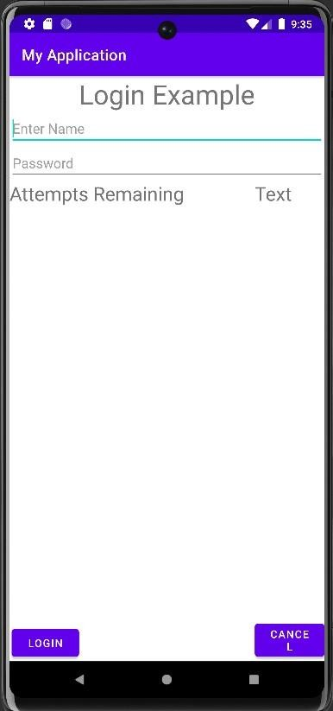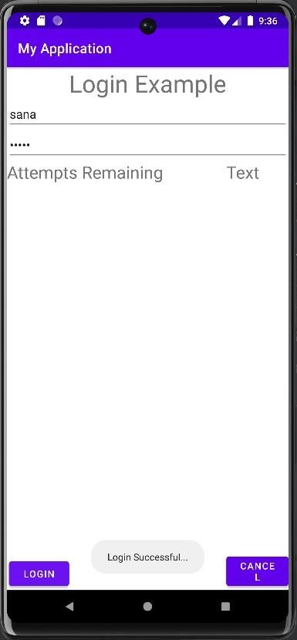

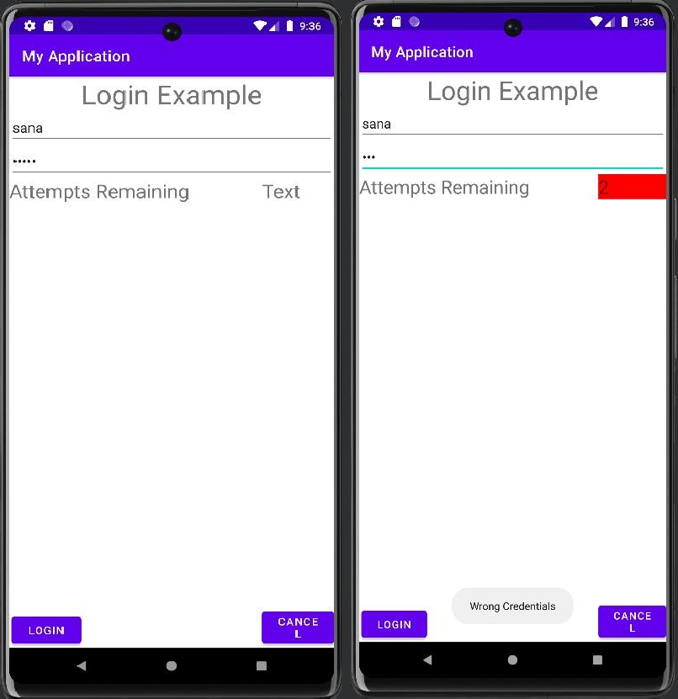

# PRACTICAL 5

## Aim: Create a application for showing Menus

### Activity_Main.xml

<?xml version="1.0" encoding="utf-8"?>

<RelativeLayout xmlns:android="[http://schemas.android.com/apk/res/android"](http://schemas.android.com/apk/res/android) xmlns:app="[http://schemas.android.com/apk/res-auto"](http://schemas.android.com/apk/res-auto) xmlns:tools="[http://schemas.android.com/tools"](http://schemas.android.com/tools) android:layout_width="match_parent" android:layout_height="match_parent"

tools:context=".MainActivity">

<TextView android:id="@+id/mn"

android:layout_width="wrap_content" android:layout_height="wrap_content" android:text="Hello World!" app:layout_constraintBottom_toBottomOf="parent" app:layout_constraintLeft_toLeftOf="parent" app:layout_constraintRight_toRightOf="parent" app:layout_constraintTop_toTopOf="parent" />

</RelativeLayout>

### MainActivity.java

package com.example.myapplication;

import androidx.annotation.NonNull;

import androidx.appcompat.app.AppCompatActivity;

import android.os.Bundle; import android.view.Menu;

import android.view.MenuInflater; import android.view.MenuItem; import android.widget.TextView;

public class MainActivity extends AppCompatActivity {

TextView mn; @Override

protected void onCreate(Bundle savedInstanceState) { super.onCreate(savedInstanceState); setContentView(R.layout.*activity_main*); mn=findViewById(R.id.*mn*);

}

public boolean onCreateOptionsMenu(Menu menu) { MenuInflater m=getMenuInflater(); m.inflate(R.menu.*menu*, menu);

return true;

}

@Override

public boolean onOptionsItemSelected(@NonNull MenuItem item) { switch (item.getItemId()) {

case R.id.*fyit*: mn.setText("FYIT"); return true;

case R.id.*syit*: mn.setText("SYIT"); return true;

case R.id.*tyit*: mn.setText("TYIT"); return true;

}

return super.onOptionsItemSelected(item);

}

}

### Menu.xml

<?xml version="1.0" encoding="utf-8"?>

<menu xmlns:android="<http://schemas.android.com/apk/res/android>">

<item

android:id="@+id/fyit" android:title="FYIT" />

<item

android:id="@+id/syit" android:title="SYIT" />

<item

android:id="@+id/tyit" android:title="TYIT" />

</menu>

**Output**

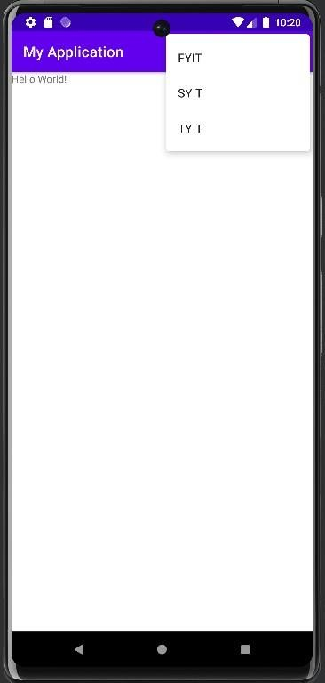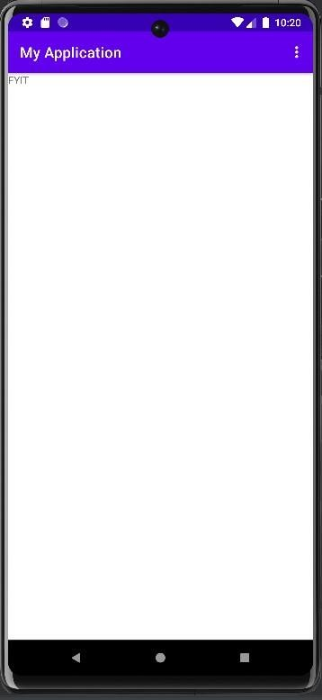

# PRACTICAL 6

## Aim: Create an application for time picker Dialog

### Activity_main.xml

<?xml version="1.0" encoding="utf-8"?>

<android.support.constraint.ConstraintLayout xmlns:android="[http://schemas.android.com/apk/res/android"](http://schemas.android.com/apk/res/android)

xmlns:app="<http://schemas.android.com/apk/res-auto>" xmlns:tools="<http://schemas.android.com/tools>" android:layout_width="match_parent" android:layout_height="match_parent" tools:context="com.example.sonal.myapplication.MainActivity">

<TextView android:id="@+id/textView2" android:layout_width="wrap_content" android:layout_height="wrap_content" android:layout_alignParentTop="true" android:layout_centerHorizontal="true" android:text="@string/time_pick"

android:textAppearance="?android:attr/textAppearanceMedium"/>

<Button android:id="@+id/set_button" android:layout_width="wrap_content" android:layout_height="wrap_content" android:layout_alignParentTop="true"

android:layout_centerHorizontal="true" android:layout_marginBottom="180dp" android:onClick="setTime" android:text="@string/time_save"/>

<TimePicker android:id="@+id/timePicker1" android:layout_width="wrap_content" android:layout_height="wrap_content" android:layout_above="@id/set_button" android:layout_centerHorizontal="true" android:layout_marginBottom="24dp"/>

<TextView android:id="@+id/textView3" android:layout_width="wrap_content" android:layout_height="wrap_content"

android:layout_alignLeft="@+id/timePicker1" android:layout_alignTop="@+id/set_button" android:layout_marginTop="40dp" android:text="@string/time_current" android:textAppearance="?android:attr/textAppearanceMedium"/>

<TextView android:id="@+id/textView" android:layout_width="wrap_content" android:layout_height="wrap_content"

android:layout_below="@+id/textView3"

android:layout_centerHorizontal="true" android:text="@string/time_selected" android:textAppearance="?android:attr/textAppearanceMedium"/>

</android.support.constraint.ConstraintLayout>

### MainActivity.java

package com.example.sonal.myapplication;

import android.support.v7.app.AppCompatActivity; import android.os.Bundle;

import java.util.Calendar; import java.lang.String; import android.view.Menu; import android.view.View;

import android.widget.TextView; import android.widget.TimePicker;

public class MainActivity extends AppCompatActivity { private TimePicker timePicker1;

private TextView time; private Calendar calendar; private String format=""; @Override

protected void onCreate(Bundle savedInstanceState) { super.onCreate(savedInstanceState); setContentView(R.layout.activity_main); timePicker1=(TimePicker)findViewById(R.id.timePicker1); time=(TextView)findViewById(R.id.textView);

calendar=Calendar.getInstance();

int hour=calendar.get(Calendar.HOUR_OF_DAY); int min=calendar.get(calendar.MINUTE); shoeTime(hour,min);

}

public void setTime(View view)

{

int hour=timePicker1.getHour(); int min=timePicker1.getMinute(); shoeTime(hour, min);

}

public void shoeTime(int hour,int min)

{

if ((hour==0))

{

hour+=12; format="AM";

}

else if (hour==12)

{

format="PM";

}

else if (hour>12)

{

hour=12;

format="PM";

}

else

{

format="AM";

}

time.setText(new StringBuilder().append(hour).append(":").append(min).append("").append(format));

}

}

### String.xml

<resources>

<string name="app_name">My Application</string>

<string name="action_settings">Settings</string>

<string name="time_picker_example">Time Picker Example</string>

<string name="time_pick">Pick the time and press save button</string>

<string name="time_save">Save</string>

<string name="time_selected"></string>

<string name="time_current">The Time is:</string>

</resources>

**Output**

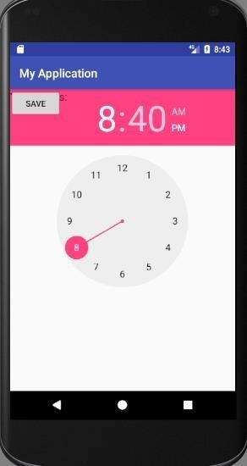

### MainActivity.java

package com.example.sonal.myapplication; import android.os.Build;

import android.support.annotation.RequiresApi;

import android.support.v7.app.AppCompatActivity; import android.os.Bundle;

import android.view.View;

import android.widget.TimePicker; import android.widget.Button; import android.widget.Toast;

public class MainActivity extends AppCompatActivity { private TimePicker time_picker;

private Button button_show_Time; @Override

protected void onCreate(Bundle savedInstanceState) { super.onCreate(savedInstanceState); setContentView(R.layout.activity_main); showTime();

}

public void showTime()

{

time_picker=(TimePicker)findViewById(R.id.timePicker); button_show_Time=(Button)findViewById(R.id.button); button_show_Time.setOnClickListener(

new View.OnClickListener()

{

@Override

@RequiresApi(api = Build.VERSION_CODES.M) public void onClick(View v)

{

Toast.makeText(getBaseContext(),time_picker.getHour()+ ":"+ time_picker.getMinute(), Toast.LENGTH_SHORT).show();

}

}

);

}

}

### Activity_main.xml

<?xml version="1.0" encoding="utf-8"?>

<android.support.constraint.ConstraintLayout xmlns:android="[http://schemas.android.com/apk/res/android"](http://schemas.android.com/apk/res/android)

xmlns:app="<http://schemas.android.com/apk/res-auto>" xmlns:tools="<http://schemas.android.com/tools>" android:layout_width="match_parent" android:layout_height="match_parent" tools:context="com.example.sonal.myapplication.MainActivity">

<TimePicker android:id="@+id/timePicker" android:layout_width="wrap_content" android:layout_height="wrap_content" tools:layout_editor_absoluteX="0dp" tools:layout_editor_absoluteY="16dp" />

<Button android:id="@+id/button"

android:layout_width="wrap_content" android:layout_height="wrap_content" android:text="show Time" tools:layout_editor_absoluteX="148dp" tools:layout_editor_absoluteY="396dp" />

</android.support.constraint.ConstraintLayout>

Datepickerpackage com.example.sonal.myapplication; import android.app.DatePickerDialog;

import android.app.Dialog;

import android.support.v7.app.AppCompatActivity; import android.os.Bundle;

import android.view.View; import android.widget.Button;

import android.widget.DatePicker; import android.widget.Toast; import java.util.Calendar;

public class MainActivity extends AppCompatActivity { Button btn;

int year_x,month_x,day_x; static final int DIALOG_ID=0; @Override

protected void onCreate(Bundle savedInstanceState) { super.onCreate(savedInstanceState); setContentView(R.layout.activity_main);

final Calendar cal=Calendar.getInstance(); year_x=cal.get(Calendar.YEAR); month_x=cal.get(Calendar.MONTH); day_x=cal.get(Calendar.DAY_OF_MONTH); showDialogonButtonclick();

}

public void showDialogOnButtonClick() { btn = (Button) findViewById(R.id.button); btn.setOnClickListener(

new View.OnClickListener() { @Override

public void onClick(View v) { showDialog(DIALOG_ID);

}

}

);

}

protected Dialog OnCreateDialog(int id)

{

if (id==DIALOG_ID)

return new DatePickerDialog(this,dpickerListener,year_x,month_x,day_x); return null;

}

private DatePickerDialog.OnDateSetListener dpickerListener

= new DatePickerDialog.OnDateSetListener()

{

@Override

public void onDateSet(DatePicker view,int year,int monthOfYear,int dayOfMonth)

{

year_x=year; month_x=monthOfYear+1; day_x=dayOfMonth;

Toast.makeText(MainActivity.this,year_x+"/" +month_x+"/"+day_x, Toast.LENGTH_LONG).show();

}

};

}

<?xml version="1.0" encoding="utf-8"?>

<android.support.constraint.ConstraintLayout xmlns:android="[http://schemas.android.com/apk/res/android"](http://schemas.android.com/apk/res/android)

xmlns:app="<http://schemas.android.com/apk/res-auto>" xmlns:tools="<http://schemas.android.com/tools>" android:layout_width="match_parent" android:layout_height="match_parent" tools:context="com.example.sonal.myapplication.MainActivity">

<Button android:id="@+id/button"

android:layout_width="wrap_content" android:layout_height="wrap_content" android:text="SHOW DATE PICKER DIALOG"

tools:layout_editor_absoluteX="147dp" tools:layout_editor_absoluteY="123dp" />

</android.support.constraint.ConstraintLayout>

**Output**

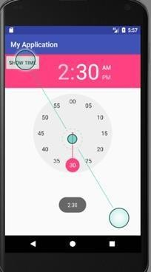

# PRACTICAL 7

## Aim: Create an Android application to pass the data (Program Intent passing)

### Activity_Main.xml

<?xml version="1.0" encoding="utf-8"?>

<RelativeLayout xmlns:android="<http://schemas.android.com/apk/res/android>" xmlns:app="[http://schemas.android.com/apk/res-auto"](http://schemas.android.com/apk/res-auto) xmlns:tools="[http://schemas.android.com/tools"](http://schemas.android.com/tools) android:layout_width="match_parent" android:layout_height="match_parent"

tools:context=".MainActivity">

<LinearLayout android:layout_width="match_parent" android:layout_height="match_parent" android:orientation="vertical">

<TextView android:layout_width="fill_parent" android:layout_height="wrap_content" android:layout_marginTop="10dp" android:gravity="center_horizontal"

android:text="Input yourName"></TextView>

<TableLayout android:id="@+id/tableLayout1" android:layout_width="match_parent" android:layout_height="wrap_content" android:layout_margin="10dp" android:stretchColumns="1">

<TableRow android:id="@+id/tableRow1" android:layout_width="match_parent" android:layout_height="wrap_content">

<TextView android:id="@+id/textView1" android:layout_width="match_parent"

android:layout_height="wrap_content" android:text="FirstName"></TextView>

<EditText android:id="@+id/etFName"

android:layout_width="match_parent" android:layout_height="wrap_content" android:layout_marginLeft="5dp">

<requestFocus></requestFocus>

</EditText>

</TableRow>

<TableRow android:id="@+id/tableRow2" android:layout_width="match_parent" android:layout_height="wrap_content">

<TextView android:id="@+id/textView2" android:layout_width="match_parent" android:layout_height="wrap_content"

android:text="LastName"></TextView>

<EditText android:id="@+id/etLName"

android:layout_width="match_parent" android:layout_height="wrap_content" android:layout_marginLeft="5dp"></EditText

>

</TableRow>

</TableLayout>

<Button

android:id="@+id/btnSubmit" android:layout_width="wrap_content" android:layout_height="wrap_content" android:layout_gravity="center_horizontal" android:text="Submit"></Button>

</LinearLayout>

</RelativeLayout >

### MainActivity.java

package com.example.myapplication;

import androidx.appcompat.app.AppCompatActivity; import android.content.Intent;

import android.graphics.Color; import android.os.Bundle; import android.view.View; import android.widget.Button; import android.widget.EditText;

import android.widget.QuickContactBadge; import android.widget.TextView;

import android.widget.Toast; import java.util.Random;

public class MainActivity extends AppCompatActivity { EditText etFName;

EditText etLName;

Button btnSubmit;

@Override

protected void onCreate(Bundle savedInstanceState) { super.onCreate(savedInstanceState); setContentView(R.layout.*activity_main*);

etFName = (EditText) findViewById(R.id.*etFName*); etLName = (EditText) findViewById(R.id.*etLName*); btnSubmit = (Button) findViewById(R.id.*btnSubmit*); btnSubmit.setOnClickListener(new View.OnClickListener()

{

@Override

public void onClick(View v) { Intent intent = new

Intent(getApplicationContext(),MainActivity2.class); intent.putExtra("fname",

}

});

}

}

etFName.getText().toString()); intent.putExtra("lname",

etLName.getText().toString()); startActivity(intent);

### Activity_Main2.xml

<?xml version="1.0" encoding="utf-8"?>

<RelativeLayout xmlns:android="[http://schemas.android.com/apk/res/android"](http://schemas.android.com/apk/res/android) xmlns:app="[http://schemas.android.com/apk/res-auto"](http://schemas.android.com/apk/res-auto) xmlns:tools="[http://schemas.android.com/tools"](http://schemas.android.com/tools) android:layout_width="match_parent" android:layout_height="match_parent"

tools:context=".MainActivity2">

<TextView android:id="@+id/tvView" android:layout_width="400dp" android:layout_height="85dp"

android:layout_gravity="center_horizontal" android:layout_marginTop="20dp" android:text="Output" android:textColor="@android:color/holo_blue_dark" android:textSize="24sp"

android:textStyle="bold">

</TextView>

</RelativeLayout>

### MainActivity2.java

package com.example.myapplication;

import androidx.appcompat.app.AppCompatActivity;

import android.os.Bundle; import android.content.Intent; import android.widget.TextView;

public class MainActivity2 extends AppCompatActivity { TextView tvView;

@Override

protected void onCreate(Bundle savedInstanceState) { super.onCreate(savedInstanceState); setContentView(R.layout.*activity_main2*);

tvView = (TextView) findViewById(R.id.*tvView*); Intent intent = getIntent();

String fName = intent.getStringExtra("fname"); String lName = intent.getStringExtra("lname");

tvView.setText("Your name is: " + fName + " " + lName);

}

}

**Output**

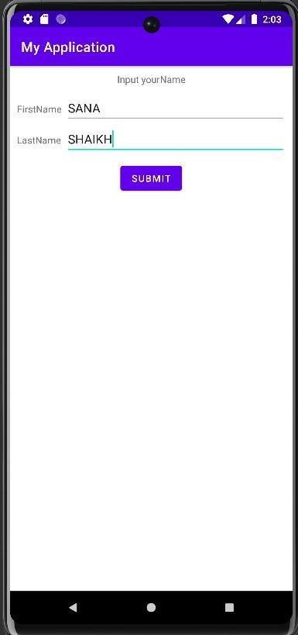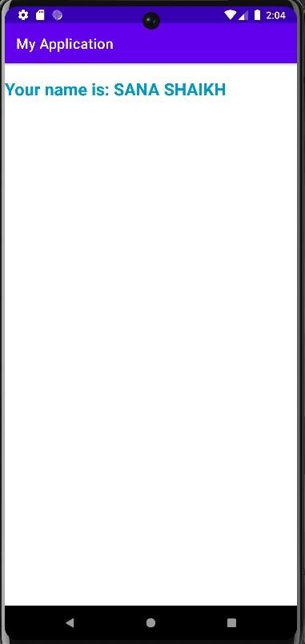

# PRACTICAL 8

## Aim: Create the media API in android to play an audio file.

### Activity_main.xml

<?xml version="1.0" encoding="utf-8"?>

<RelativeLayout xmlns:android="[http://schemas.android.com/apk/res/android"](http://schemas.android.com/apk/res/android) xmlns:app="[http://schemas.android.com/apk/res-auto"](http://schemas.android.com/apk/res-auto) xmlns:tools="[http://schemas.android.com/tools"](http://schemas.android.com/tools) android:layout_width="match_parent" android:layout_height="match_parent"

tools:context=".MainActivity">

<Button android:id="@+id/btnPlay" android:layout_width="197dp" android:layout_height="75dp"

android:layout_alignParentEnd="true" android:layout_alignParentRight="true" android:layout_alignParentBottom="true" android:layout_marginEnd="87dp" android:layout_marginRight="87dp" android:layout_marginBottom="468dp" android:text="Play Audio" android:onClick="playAudio"

/>

<Button

android:id="@+id/btnStop" android:layout_width="208dp" android:layout_height="70dp" android:layout_alignParentEnd="true" android:layout_alignParentRight="true" android:layout_alignParentBottom="true" android:layout_marginEnd="89dp" android:layout_marginRight="89dp" android:layout_marginBottom="356dp" android:text="Stop Audio" android:onClick="onPause"/>

<ImageView android:id="@+id/imageView" android:layout_width="wrap_content" android:layout_height="wrap_content" />

<ImageButton android:id="@+id/imageButton5" android:layout_width="wrap_content" android:layout_height="wrap_content" android:layout_alignParentEnd="true" android:layout_alignParentRight="true" android:layout_alignParentBottom="true" android:layout_marginEnd="66dp" android:layout_marginRight="66dp" android:layout_marginBottom="182dp" android:visibility="invisible" app:srcCompat="@drawable/song" tools:visibility="invisible" />

</RelativeLayout>

### MainActivity.java

package com.example.myapplication;

import androidx.appcompat.app.AppCompatActivity; import android.media.MediaPlayer;

import android.os.Bundle; import android.view.View;

import android.widget.ImageButton; import android.widget.Toast;

public class MainActivity extends AppCompatActivity { MediaPlayer mediaPlayer;

ImageButton ibtn;

@Override

protected void onCreate(Bundle savedInstanceState) { super.onCreate(savedInstanceState); setContentView(R.layout.*activity_main*);

mediaPlayer = MediaPlayer.create(this,R.raw.song);

}

public void playAudio(View v)

{

ibtn = findViewById(R.id.*imageButton5*); ibtn.setVisibility(View.*VISIBLE*); mediaPlayer.start();

Toast.*makeText*(this, "Music is playing, Connect Ear Phone to Listen the Ringtone", Toast.*LENGTH_SHORT*).show();

}

public void onPause(View v) { super.onPause(); mediaPlayer.release(); ibtn.setVisibility(View.*INVISIBLE*);

}

}

**Output**

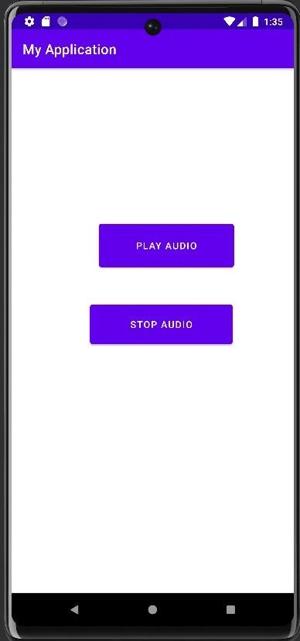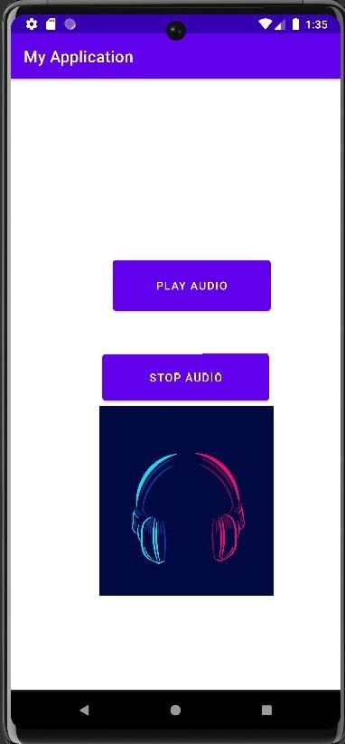

# PRACTICAL 9

## Aim: Create an android Application that open the website [www.google.com](http://www.google.com/) in the browser on the click of a button (program on internet)

### Activity_Main.xml

<?xml version="1.0" encoding="utf-8"?>

<RelativeLayout xmlns:android="[http://schemas.android.com/apk/res/android"](http://schemas.android.com/apk/res/android) xmlns:app="[http://schemas.android.com/apk/res-auto"](http://schemas.android.com/apk/res-auto) xmlns:tools="[http://schemas.android.com/tools"](http://schemas.android.com/tools) android:layout_width="match_parent" android:layout_height="match_parent"

tools:context=".MainActivity">

<EditText android:id="@+id/editText1"

android:layout_width="wrap_content" android:layout_height="wrap_content" android:layout_alignParentTop="true" android:layout_centerHorizontal="true" android:layout_marginTop="44dp" android:ems="10"/>

<Button

android:id="@+id/button1" android:layout_width="wrap_content" android:layout_height="wrap_content" android:layout_below="@+id/editText1" android:layout_centerHorizontal="true" android:layout_marginTop="54dp" android:text="Visit"/>

</RelativeLayout>

### MainActivity.java

package com.example.myapplication;

import androidx.appcompat.app.AppCompatActivity; import android.content.Intent;

import android.net.Uri; import android.view.View; import android.widget.Button;

import android.widget.EditText; import android.os.Bundle;

public class MainActivity extends AppCompatActivity { @Override

protected void onCreate(Bundle savedInstanceState) {

super.onCreate(savedInstanceState); setContentView(R.layout.*activity_main*);

final EditText editText1=(EditText)findViewById(R.id.*editText1*); Button button1=(Button)findViewById(R.id.*button1*); button1.setOnClickListener(new View.OnClickListener(){

@Override

public void onClick(View arg0){

String url=editText1.getText().toString();

Intent intent=new Intent(Intent.*ACTION_VIEW*, Uri.*parse*(url)); startActivity(intent);

}

});

}

}

**Output**

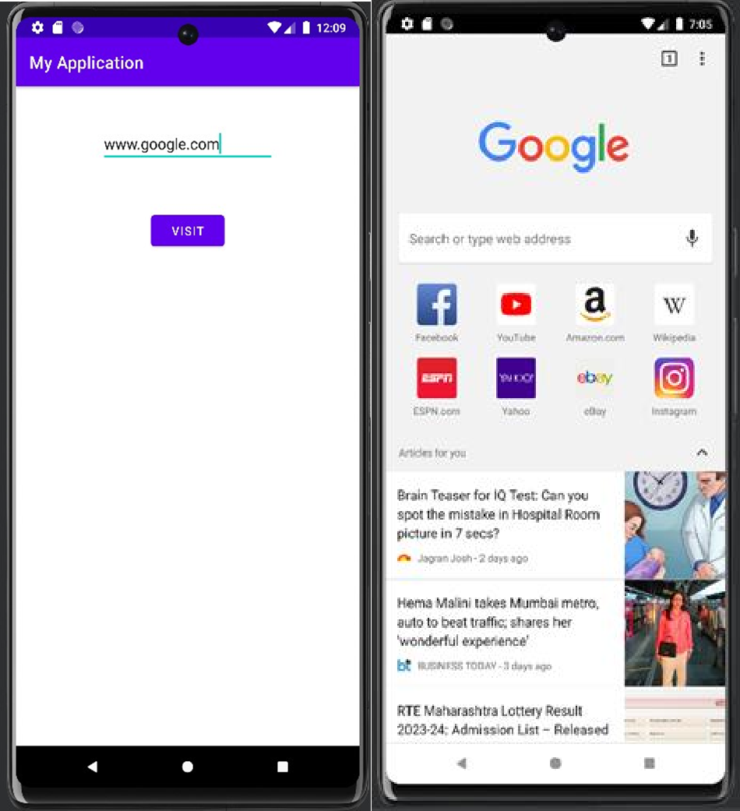

# PRACTICAL 10

## Aim: Create an android application to show the notification

### Activity_Main.xml

<?xml version="1.0" encoding="utf-8"?>

<RelativeLayout xmlns:android="[http://schemas.android.com/apk/res/android"](http://schemas.android.com/apk/res/android) xmlns:app="[http://schemas.android.com/apk/res-auto"](http://schemas.android.com/apk/res-auto) xmlns:tools="[http://schemas.android.com/tools"](http://schemas.android.com/tools) android:layout_width="match_parent"

android:layout_height="match_parent" tools:context=".MainActivity">

<ImageView android:id="@+id/imageView" android:layout_width="40dp" android:layout_height="40dp" android:layout_margin="8dp" android:layout_marginTop="16dp"

app:layout_constraintStart_toStartOf="parent" app:layout_constraintTop_toTopOf="parent" app:srcCompat="@drawable/a1" />

<Button android:text="click"

android:layout_width="wrap_content" android:layout_height="wrap_content"

android:layout_alignParentStart="true" android:layout_alignParentLeft="true" android:layout_alignParentTop="true" android:id="@+id/button" android:layout_marginTop="193dp" android:onClick="click" android:textStyle="bold" android:textSize="24sp"/>

</RelativeLayout>

### MainActivity.java

package com.example.demo.myapplication; import android.app.NotificationManager; import android.os.Bundle;

import android.support.v4.app.NotificationCompat; import android.support.v7.app.AppCompatActivity; import android.view.View;

public class MainActivity extends AppCompatActivity { @Override

protected void onCreate(Bundle savedInstanceState) { super.onCreate(savedInstanceState); setContentView(R.layout.activity_main);

}

public void click(View v)

{

NotificationCompat.Builder nb=new NotificationCompat.Builder(this); nb.setContentTitle("notification Recieved");

nb.setContentText("Your notification is be prepared for your android exams"); nb.setSmallIcon(R.drawable.a1);

NotificationManager nm =(NotificationManager)getSystemService(NOTIFICATION_SERVICE); nm.notify(0,nb.build());

nb.setPriority(0);

}

}

**Output**

